ABSTRACT

Title of Thesis:

FIRE RISK MODELING IN THE PARAGUAYAN CHACO

Paulo Caetano Medina Avalos, Master of Science in Geospatial Information Sciences, 2026

Thesis Directed By:
PhD, Associate Research Professor, Evan Ellicott, Department of Geographical Sciences

Begin typing the body of the abstract here, double-spacing throughout. Formatting for the Abstract page will continue in this template until the word “BREAK.” After the Break, a new page will be forced for the Title Page.

BREAK. [delete in final draft]

FIRE RISK MODELING IN THE PARAGUAYAN CHACO

by

Paulo Caetano Medina Avalos

Thesis submitted to the Faculty of the Graduate School of the
University of Maryland, College Park, in partial fulfillment
of the requirements for the degree of
Master of Science in Geospatial Information Sciences
2026

Advisory Committee:
Professor PhD, Evan Ellicott, Chair
PhD, Jack Ma
PhD, Jonathan Resop

© Copyright by
Paulo Caetano Medina Avalos
2026

Preface
If needed.

Foreword

If needed.

Dedication
If needed.

Acknowledgements
If needed.

Table of Contents

ABSTRACT 1
Preface ii
Foreword iii
Dedication iv
Acknowledgements v
Table of Contents vi
List of Tables x
List of Figures xi
List of Abbreviations xii
1. INTRODUCTION 1
2. LITERATURE REVIEW 2
2.1. Wildfire Hazard: Process Fundamentals and Contemporary Drivers 2
2.1.1. Fire as an Earth system process 2
2.1.2. Wildland Fire 3
2.2. Wildfire risk modeling 4
2.3. Asset-specific vulnerabilities 4
2.4. Research Gaps 4
Section 5 4
Section 6 4
Literature Review 5
Section 1 5
Subsection 1 5
Subsection 2 5
Subsection 3 5
Section 2 5
Subsection 1 5
Subsection 2 5
Subsection 3 5
Section 3 5
Subsection 1 5
Subsection 2 5
Subsection 3 5
Section 4 6
Subsection 1 6
Subsection 2 6
Subsection 3 6
Section 5 6
Subsection 1 6
Subsection 2 6
Subsection 3 6
Section 6 6
Subsection 1 6
Subsection 2 6
Subsection 3 6
Objectives 7
Section 1 7
Subsection 1 7
Subsection 2 7
Subsection 3 7
Section 2 7
Subsection 1 7
Subsection 2 7
Subsection 3 7
Section 3 7
Subsection 1 7
Subsection 2 7
Subsection 3 7
Section 4 8
Subsection 1 8
Subsection 2 8
Subsection 3 8
Section 5 8
Subsection 1 8
Subsection 2 8
Subsection 3 8
Section 6 8
Subsection 1 8
Subsection 2 8
Subsection 3 8
Study Area 9
Section 1 9
Subsection 1 9
Subsection 2 9
Subsection 3 9
Section 2 9
Subsection 1 9
Subsection 2 9
Subsection 3 9
Section 3 9
Subsection 1 9
Subsection 2 9
Subsection 3 9
Section 4 10
Subsection 1 10
Subsection 2 10
Subsection 3 10
Section 5 10
Subsection 1 10
Subsection 2 10
Subsection 3 10
Section 6 10
Subsection 1 10
Subsection 2 10
Subsection 3 10
Data 12
Section 1 12
Subsection 1 12
Subsection 2 12
Subsection 3 12
Section 2 12
Subsection 1 12
Subsection 2 12
Subsection 3 12
Section 3 12
Subsection 1 12
Subsection 2 12
Subsection 3 12
Section 4 13
Subsection 1 13
Subsection 2 13
Subsection 3 13
Section 5 13
Subsection 1 13
Subsection 2 13
Subsection 3 13
Section 6 13
Subsection 1 13
Subsection 2 13
Subsection 3 13
Methodology 14
Section 1 14
Subsection 1 14
Subsection 2 14
Subsection 3 14
Section 2 14
Subsection 1 14
Subsection 2 14
Subsection 3 14
Section 3 14
Subsection 1 14
Subsection 2 14
Subsection 3 14
Section 4 15
Subsection 1 15
Subsection 2 15
Subsection 3 15
Section 5 15
Subsection 1 15
Subsection 2 15
Subsection 3 15
Section 6 15
Subsection 1 15
Subsection 2 15
Subsection 3 15
Results and Discussion 16
Discussion 17
Glossary 19
Bibliography 20

This Table of Contents is automatically generated by MS Word, linked to the Heading formats used within the Chapter text.

List of Tables

If needed.

List of Figures
Figure 1. Fire triangles across different scales. 3
Figure 2. Main drivers of wildfire, adapted from Yang et al. 2021. 4

List of Abbreviations
HVA: High Value Asset
GIS: Geographic Information Sciences

1. INTRODUCTION

2. LITERATURE REVIEW

2.1. Wildfire Hazard: Process Fundamentals and Contemporary Drivers

2.1.1. Fire as an Earth system process
Fire is understood to be a natural and recurrent earth system process, contributing to the delineation of ecological boundaries, influencing geological cycles, and affecting atmospheric dynamics. These effects can be seen in ecoregions shaped on fire adaptation, fire effects on soil properties, and gases released (Bowman et al. 2009; Harrison et al. 2021; Shakesby and Doerr 2006). Fire itself is considered to be a core ecological process across the planet (Cochrane and Ryan 2009).

Fire is a type of chemical reaction known as combustion. It liberates CO2, water in the form of steam, and stored energy in the form of light and heat (Pyne et al. 1996; Cochrane and Ryan 2009). Combustion reaction:

$${(C_{6}H_{1}2O_{6})}_{n}→6_{n}CO_{2}+6nH_{2}O+energy$$

This reaction is further decomposed in three subprocesses: preignition, ignition, and combustion. The first process, preignition, is an endothermic process where fuel temperature is raised to ignition temperatures. In the context of biomass, this temperature is around 350 C, usually involving the complete evaporation of water and terpen contents (Cochrane and Ryan 2009). Ignition is the transition between the endothermic and exothermic phases of a fire. At this point, the fuel temperature has been raised to the point where an external source of heat is not necessary to sustain combustion. Once this point is reached, the exothermic output of the combustion is enough to bring surrounding fuel to ignition temperatures (Cochrane and Ryan 2009; Pyne et al. 1996).

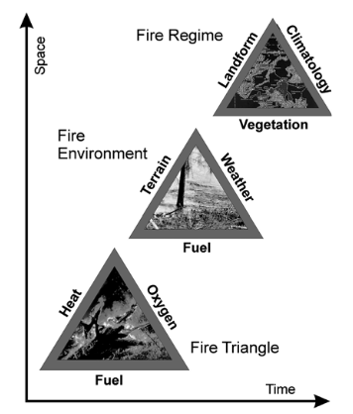
Figure 1. Fire triangles across different scales.
Fire takes three elements to occur: heat, oxygen, and fuel. As we move forward in space and time, these elements change and vary with scale. To visualize the three fire fundamental elements, a triangle is often used. To better exemplify the change of these elements with scale as we discuss wildfires, Cochrane and Ryan 2009 proposed figure 1.

2.1.2. Wildland Fire
Although there are different approaches and definitions, wildfires are widely understood as "any unplanned and uncontrolled fire started in shrubs or forest" (Tedim and Leone 2020). There is no distinction based on the source of ignition, so these fires can be naturally, intentionally, or accidentally set (Cochrane and Ryan 2009). Usually, natural causes of ignitions are lightnings and in rare cases caused by spontaneous ignitions (Pyne et al. 1996).

The main drivers of wildland fires can be divided into 4 groups: topography, vegetation, climatic variables, and human activity. These relationships are further subdivided by different attributes.

These factors influence the dominant mechanisms of heat transfer in a fire event, which influences the rate of spread of the wildfire (Pyne et al. 1996). Of particular importance are:

- Fuel arrangement
- Speed of the wind acting on the fire
- Slope

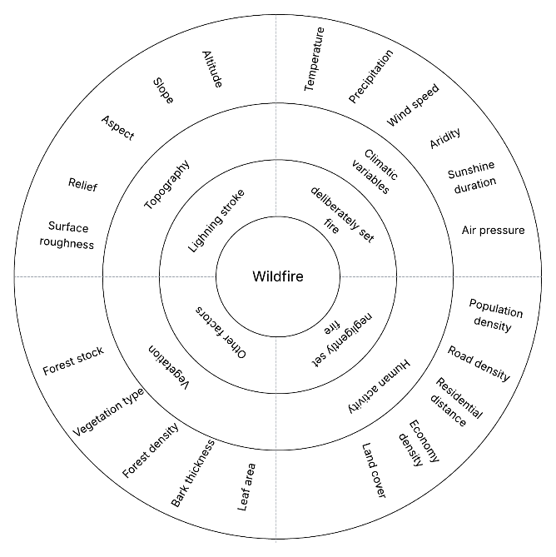
Figure 2. Main drivers of wildfire, adapted from Yang et al. 2021.

2.2. Wildfire risk modeling

2.3. Asset-specific vulnerabilities

2.4. Research Gaps

Section 5

Section 6

Literature Review

Section 1

Subsection 1

Subsection 2

Subsection 3

Section 2

Subsection 1

Subsection 2

Subsection 3

Section 3

Subsection 1

Subsection 2

Subsection 3

Section 4

Subsection 1

Subsection 2

Subsection 3

Section 5

Subsection 1

Subsection 2

Subsection 3

Section 6

Subsection 1

Subsection 2

Subsection 3

Objectives

Section 1

Subsection 1

Subsection 2

Subsection 3

Section 2

Subsection 1

Subsection 2

Subsection 3

Section 3

Subsection 1

Subsection 2

Subsection 3

Section 4

Subsection 1

Subsection 2

Subsection 3

Section 5

Subsection 1

Subsection 2

Subsection 3

Section 6

Subsection 1

Subsection 2

Subsection 3

Study Area

Section 1

Subsection 1

Subsection 2

Subsection 3

Section 2

Subsection 1

Subsection 2

Subsection 3

Section 3

Subsection 1

Subsection 2

Subsection 3

Section 4

Subsection 1

Subsection 2

Subsection 3

Section 5

Subsection 1

Subsection 2

Subsection 3

Section 6

Subsection 1

Subsection 2

Subsection 3

Data

Section 1

Subsection 1

Subsection 2

Subsection 3

Section 2

Subsection 1

Subsection 2

Subsection 3

Section 3

Subsection 1

Subsection 2

Subsection 3

Section 4

Subsection 1

Subsection 2

Subsection 3

Section 5

Subsection 1

Subsection 2

Subsection 3

Section 6

Subsection 1

Subsection 2

Subsection 3

Methodology

Section 1

Subsection 1

Subsection 2

Subsection 3

Section 2

Subsection 1

Subsection 2

Subsection 3

Section 3

Subsection 1

Subsection 2

Subsection 3

Section 4

Subsection 1

Subsection 2

Subsection 3

Section 5

Subsection 1

Subsection 2

Subsection 3

Section 6

Subsection 1

Subsection 2

Subsection 3

Results and Discussion

Discussion

Appendices

If needed.

Glossary

If needed.

Bibliography

